
- How to test and record your blood glucose (glucose monitoring)
- What to eat
  - Nuts
  - Whole grains
  - Citrus fruits
- What foods to watch out for
  - Sugar
  - Fats
  - Starchy Vegetables
  - Alcohol
- How to recognize low and high blood sugar
  - Shaky, sweaty and/or hungry

How a Physical Therapy can help with Diabetes Mellitus
Diabetes has been increasing since diabetes was redefined. It is very likely that physical therapist will be treating patients who have diabetes as a coexisting medical condition or who are being treated for conditions, such as stroke or amputation
Physical therapists are experts in restoring and improving human motion, and can play an integral role in the management of diabetes. They manage diabetes by supervising exercise programs and by providing treatment of complications. Managing your diabetes can lower your risk of resulting health issues. Diabetes management includes controlling your blood sugar (glucose), lowering your blood pressure and cholesterol, maintaining a healthy weight, and exercising. Patients that are at risk for falls should be referred to an exercise physiologist and/or physical therapist for muscle strengthening and balance training in a safe environment.

Jimmy Trinh

PTA-1010-022
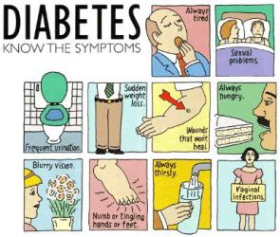

Management skills

diabetes mellitus Type 2


- The PT may adapt some examinations procedures to be more appropriate for the age.

- Strength is examined in terms of function.

Tests and measures

- Aerobic capacity and endurance
- Human body measurements
- Pain
- posture
- Motor function
- Muscle performance
- Gait and balance

Facts about Diabetes Mellitus Type 2

• Type 2 diabetes is the most common type of diabetes. About 90 to 95% of people with diabetes have type 2 diabetes.

- Some people with type 2 diabetes don’t produce enough insulin.

- Being overweight (BMI greater than 25) increases your risk of developing type 2 diabetes

Diagnosis of Diabetes Mellitus
The term "diabetes mellitus" refers to a group of diseases that affect how your body uses blood glucose, commonly called blood sugar. Diabetes Mellitus affects 10% to 20% of Americans over the age of 60 years. Type 2 diabetes mellitus occurs when the pancreas (an organ in the abdomen) produces insufficient amounts of the hormone insulin and/or the body becomes resistant to normal or even high levels of insulin. This causes high blood sugar (glucose) levels, which can lead to a number of complications if untreated.

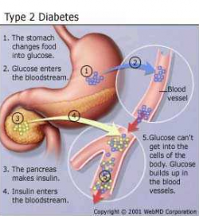
Treatments
The goal of the treatment is to lower high blood glucose levels. The long-term goals of treatment are to prevent problems from diabetes. Here is some example of treatments for diabetes mellitus.
- The main treatment for type 2 diabetes is exercise and diet.
- Metformin is often the first medicine that is advised for type 2 diabetes. It works by reducing the amount of glucose that your liver releases into the bloodstream.
- Diabetes medications and insulin therapy

